Procedure for the
Management of Nonconformity

Security Classification: Restricted

Document Reference: ISMS10002
Version: 1.0
Draft 1

Document Author:

Document Owner:

Revision History

Version | Date | Change Number | Summary of Changes

Document Review

Date of Next Scheduled Review

Distribution

Name | Title

Approval

Name | Position | Signature | Date

Contents

1 Introduction 5
2 Nonconformity Management Process 6
2.1 Process Diagram 6
2.2 Identifying Non-Conformities 7
2.3 Evaluation and Cause Determination 7
2.4 Approval and Prioritisation 7
2.5 Management and Review 8

Definition of Terms

Within the Information Security Management System (ISMS) there will sometimes be areas identified that are not as the ISO/IEC 27001 standard says they should be. These are termed “nonconformities”, and they represent opportunities for improvement within the ISMS.

Nonconformities will vary in importance from the very small, which may be addressed as part of day-to-day management, to the possibly very large, which may require that a project is put in place to manage the degree of change required to correct it.

It is important that a process is in place to recognise when nonconformity occurs and to assess and deal with its effects and the actions required to correct it.

Nonconformity Management Process

Process Diagram

The process for identifying and managing nonconformities is summarised in the diagram below.

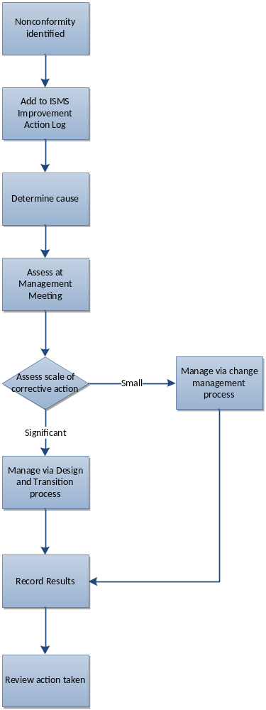

Figure 1 – Management of Nonconformity Process

The detail of the above steps is described in the following sections.

Identifying non-conformities

Non-conformities may be identified from any source and the ACG ICT-Modernisation will encourage personnel and stakeholders to propose ways in which they can be addressed. Such non-conformities may be identified from:

- Security reviews
- Team meetings
- Risk assessments.
- User surveys
- Internal and external audits

However, the above is not an exhaustive list.

Once identified, the non-conformity will be documented within ISMS10003 ISMS Improvement Action Log with a status of “Logged”. At this stage the action to correct the non-conformity has not necessarily been determined. As much detail as possible should be specified as to the exact nature of the non-conformity.

Evaluation and Cause Determination

Once logged, the non-conformity will be evaluated by the Officer-In-Charge of Continual Improvement to assess its importance and severity and what needs to be done to correct it. Other parties may be consulted during this stage to understand both the underlying causes and the implications and mechanics of correcting it.

Approval and Prioritisation

Once the corrective action has been successfully identified, it must be determined whether there is sufficient resource to implement it. The expected benefits of correcting the non-conformity will also be documented in measureable terms where possible.

If the corrective action required to address the non-conformity is approved, its status is changed to “Approved”.

The corrective action will now be prioritised against the others on the list to determine the relative allocation of resources and the likely timeframe of the improvement. A scale of High, Medium, and Low is used.

Management and Review

Approved corrective actions will be managed and actions recorded via the ISMS Improvement Action Log and reviewed on a regular basis. Where the corrective action requires a configuration item to be changed, a change request will be raised, and the action will be performed under the control of the change management process. The change request number will be recorded against the ISMS improvement record in the ISMS Improvement Action Log.

For major changes, the ISMS improvement process will interface with the Design and Transition of a New or Changed Service process which will ensure the improvement project is managed effectively.

Corrective actions will be categorised according to the area of the Information Security Management System they impact, and reports produced on the number raised, approved and successfully implemented.

Once implemented, the effect of the corrective action will be evaluated against the expected impact. If the benefits expected are not achieved, the reasons for this will be investigated as part of the regular review meeting.

